Restaurant Landing Page Project

Submitted By: Abhishek Paul Johnson, Vinola Fiona Rasquinha, Liya Babu  
Roll Number: 2462008, 2462170, 2462108  
College Email: [abhishek.paul@btech.christuniversity.in](mailto:abhishek.paul@btech.christuniversity.in) [vinola.fiona@btech.christuniversity.in](mailto:vinola.fiona@btech.christuniversity.in), [liya.babu@btech.christuniversity.in](mailto:liya.babu@btech.christuniversity.in)   
  
Course: UI/UX Design Fundamentals  
Instructor Name: Ms. Nagaveena  
Institution: Christ University

Date of Submission: 12/08/2025

# Abstract

This project involves designing and developing a visually appealing, single-page website for a fictional restaurant. The goal was to create a brand-aligned, user-friendly layout using HTML5 and CSS3, highlighting menu offerings, the restaurant’s story, and contact details. The warm color palette, high-quality food images, and responsive layout are used to reflect the ambiance and identity of the restaurant. CSS Flexbox and Grid ensure that the design adapts across devices, from large desktop screens to mobile phones. The outcome is a fully functional, visually coherent, and accessible landing page that could be adapted for a real restaurant.

# Objectives

1. Design a one-page restaurant website highlighting the menu and contact details.  
2. Apply thematic branding using warm color tones, typography, and high-quality imagery.  
3. Use CSS layout techniques (Flexbox and Grid) to ensure consistent alignment and spacing.  
4. Implement hover effects on menu items for interactivity.  
5. Ensure responsiveness and accessibility across multiple devices.

# Scope of the Project

Inclusions:  
- Header with restaurant name and navigation links.  
- Hero image with welcome message.  
- Menu with three categories: Starters, Mains, Desserts.  
- About Us section with text and imagery.  
- Contact section with icons for address, phone, and opening hours.  
- Footer with social media links and newsletter subscription placeholder.  
  
Exclusions:  
- No backend or server-side integration.  
- No JavaScript animations or lightbox features.

Target Devices: Desktop, tablet, and mobile.

# Tools & Technologies Used

|  |  |
| --- | --- |
| Tool/Technology | Purpose |
| HTML5 | Semantic markup for content structure |
| CSS3 | Styling, layout, responsiveness, hover effects |
| VS Code | Code editor for development |
| Chrome DevTools | Testing and debugging |
| Font Awesome | Scalable icons for contact info and social media |
| Unsplash/Pexels | Free high-quality images |

# HTML Structure Overview

The HTML structure uses semantic tags like <header>, <nav>, <section>, and <footer>. Menu items are arranged inside <div> containers with images and descriptions.

# CSS Styling Strategy

The styling uses an external stylesheet (style.css) and applies a warm color palette. Flexbox is used for alignment, Grid for menu layout, and hover effects for menu items. Media queries are used for responsiveness.

# Key Features

- Warm color theme matching restaurant ambiance.  
- Responsive design using Flexbox and Grid.  
- Hover zoom effects on menu items.  
- Contact section with icons.  
- Footer with social media links and newsletter form placeholder.

# Challenges Faced & Solutions

1. Text readability on hero image → Added semi-transparent overlay.  
2. Even spacing of menu cards → Used CSS Grid with gap property.  
3. Image distortion on resize → Used object-fit: cover.

# Outcome

The final design is clean, functional, and adaptable for any restaurant brand. This project improved my HTML/CSS skills and knowledge of UI/UX principles.

# Future Enhancements

- Add JavaScript for interactivity.  
- Backend integration for contact and newsletter forms.  
- CSS animations for smooth transitions.  
- Dark mode toggle.

# Sample Code

<!DOCTYPE html>

<html lang="en">

<head>

<meta charset="UTF-8">

<meta name="viewport" content="width=device-width, initial-scale=1.0">

<title>Spice Symphony Restaurant</title>

<link rel="stylesheet" href="restaurant.css">

<link rel="stylesheet" href="https://cdnjs.cloudflare.com/ajax/libs/font-awesome/6.5.0/css/all.min.css">

</head>

<body>

<!-- HEADER -->

<header>

<div class="logo">SPICE SYMPHONY</div>

<nav>

<ul>

<li><a href="#menu">Menu</a></li>

<li><a href="#about">About Us</a></li>

<li><a href="#contact">Contact</a></li>

</ul>

</nav>

</header>

<!-- HERO -->

<section class="hero">

<div class="hero-text">

<h1>Welcome to Spice Symphony</h1>

<p>Delicious food, warm ambiance, unforgettable taste</p>

</div>

</section>

<!-- MENU -->

<section id="menu">

<h2>Our Menu</h2>

<!-- Starters -->

<div class="menu-category">

<h3>Starters</h3>

<div class="menu-grid">

<div class="menu-item">

<img src="images/food/starter1.jpeg" alt="Soup">

<h4>Soup</h4>

<p>₹150</p>

</div>

<div class="menu-item">

<img src="images/food/starter2.jpeg" alt="Cheese Balls">

<h4>Cheese Balls</h4>

<p>₹120</p>

</div>

<div class="menu-item">

<img src="images/food/starter3.jpeg" alt="Garlic Bread">

<h4>Garlic Bread</h4>

<p>₹100</p>

</div>

</div>

</div>

<!-- Mains -->

<div class="menu-category">

<h3>Mains</h3>

<div class="menu-grid">

<div class="menu-item">

<img src="images/food/main1.jpeg" alt="Grilled Chicken">

<h4>Grilled Chicken</h4>

<p>₹350</p>

</div>

<div class="menu-item">

<img src="images/food/main2.jpeg" alt="Dragon Chicken">

<h4>Dragon Chicken</h4>

<p>₹250</p>

</div>

<div class="menu-item">

<img src="images/food/main3.jpeg" alt="chicken Biryani">

<h4>Chicken Biryani</h4>

<p>₹200</p>

</div>

</div>

</div>

<!-- Desserts -->

<div class="menu-category">

<h3>Desserts</h3>

<div class="menu-grid">

<div class="menu-item">

<img src="images/food/dessert1.jpeg" alt="Chocolate Cake">

<h4>Chocolate Cake</h4>

<p>₹180</p>

</div>

<div class="menu-item">

<img src="images/food/dessert2.jpeg" alt="Ice Cream">

<h4>Ice Cream </h4>

<p>₹150</p>

</div>

<div class="menu-item">

<img src="images/food/dessert3.jpeg" alt="Gulab Jamun">

<h4>Gulab Jamun</h4>

<p>₹100</p>

</div>

</div>

</div>

</section>

<!-- ABOUT US -->

<section id="about">

<div class="about-container">

<img src="images/food/restaurant.jpeg" alt="Restaurant Interior">

<div class="about-text">

<h2>About Us</h2>

<p>At Spice Symphony, we believe food is an emotion. Our chefs craft every dish with passion and the freshest ingredients, served in an ambiance that feels like home. From traditional recipes to modern delicacies, we have something for every taste.</p>

</div>

</div>

</section>

<!-- CONTACT -->

<section id="contact">

<h2>Contact Us</h2>

<div class="contact-info">

<div><i class="fas fa-map-marker-alt"></i> Kanmanike, Kengeri, Bangalore</div>

<div><i class="fas fa-phone"></i> +91 98765 43210</div>

<div><i class="fas fa-clock"></i> Mon - Sun: 10 AM - 11 PM</div>

</div>

</section>

<!-- FOOTER -->

<footer>

<div class="newsletter">

<h3>Subscribe to Our Newsletter</h3>

<form>

<input type="email" placeholder="Enter your email" required>

<button type="submit">Subscribe</button>

</form>

</div>

<div class="social-icons">

<a href="#"><i class="fab fa-facebook"></i></a>

<a href="#"><i class="fab fa-instagram"></i></a>

<a href="#"><i class="fab fa-twitter"></i></a>

</div>

<p>&copy; 2025 Spice Symphony. All Rights Reserved.</p>

</footer>

</body>

</html>

/* Reset some defaults */

* {

margin: 0;

padding: 0;

box-sizing: border-box;

}

body {

font-family: 'Segoe UI', sans-serif;

background-color: #fdfdfd;

color: #333;

line-height: 1.6;

}

/* Header */

header {

display: flex;

justify-content: space-between;

align-items: center;

background-color: #d35400;

padding: 15px 30px;

color: #fff;

}

.logo {

font-size: 24px;

font-weight: bold;

}

nav ul {

list-style: none;

display: flex;

gap: 20px;

}

nav a {

color: #fff;

text-decoration: none;

font-weight: 500;

}

/* Hero Section */

.hero {

background: url('images/food/restaurant.jpeg') no-repeat center center/cover;

height: 300px;

display: flex;

justify-content: center;

align-items: center;

color: #fff;

text-align: center;

}

.hero-text h1 {

font-size: 40px;

margin-bottom: 10px;

}

/* Menu */

#menu {

padding: 50px 30px;

background-color: #f9f9f9;

}

#menu h2 {

text-align: center;

margin-bottom: 30px;

font-size: 32px;

}

.menu-category {

margin-bottom: 50px;

}

.menu-category h3 {

margin-bottom: 20px;

font-size: 24px;

border-bottom: 2px solid #d35400;

display: inline-block;

padding-bottom: 5px;

}

.menu-grid {

display: flex;

gap: 30px;

flex-wrap: wrap;

justify-content: flex-start;

margin-top: 20px;

}

.menu-item {

flex: 1 1 200px;

max-width: 200px;

text-align: center;

border-radius: 10px;

padding: 10px;

background-color: #fff;

box-shadow: 0 2px 6px rgba(0, 0, 0, 0.1);

transition: transform 0.2s ease-in-out;

}

.menu-item:hover {

transform: translateY(-5px);

}

.menu-item img {

width: 100%;

height: 150px;

object-fit: cover;

border-radius: 8px;

margin-bottom: 10px;

}

.menu-item h4 {

font-size: 18px;

margin: 5px 0;

}

.menu-item p {

font-size: 16px;

color: #555;

}

/* About */

#about {

display: flex;

align-items: center;

padding: 50px 30px;

gap: 30px;

flex-wrap: wrap;

}

.about-container img {

width: 400px;

border-radius: 10px;

}

.about-text {

flex: 1;

}

.about-text h2 {

font-size: 28px;

margin-bottom: 15px;

}

/* Contact */

#contact {

padding: 50px 30px;

background-color: #f1f1f1

}

# Screenshot of Final Output

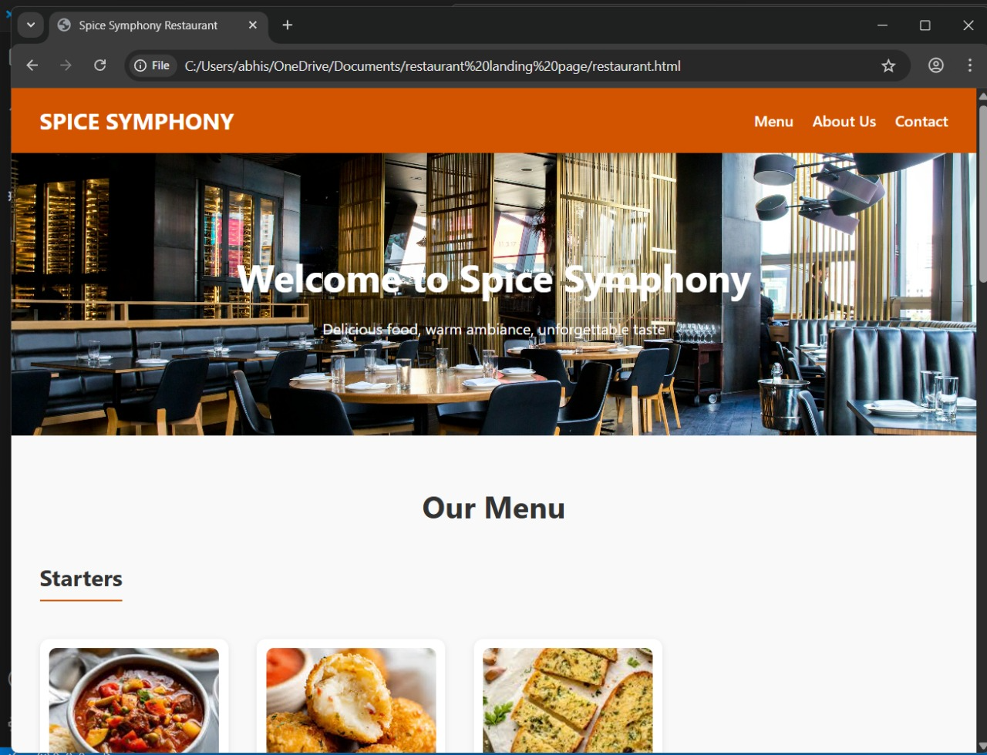

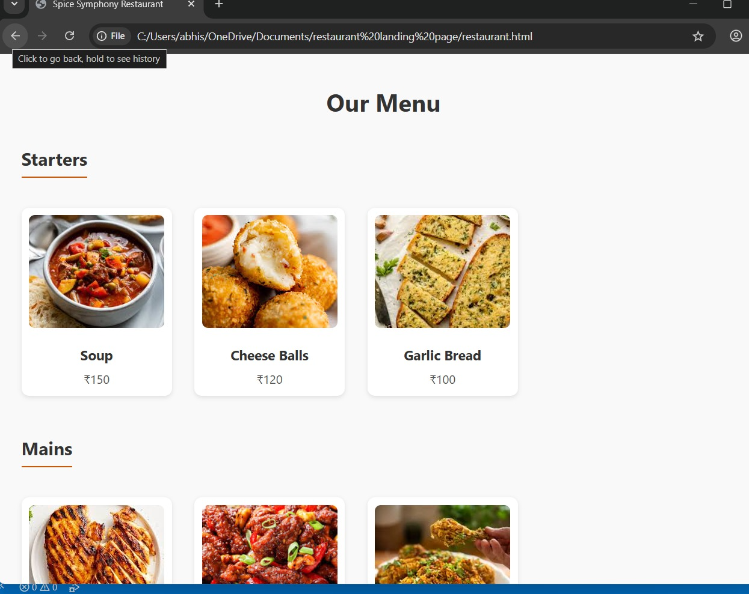

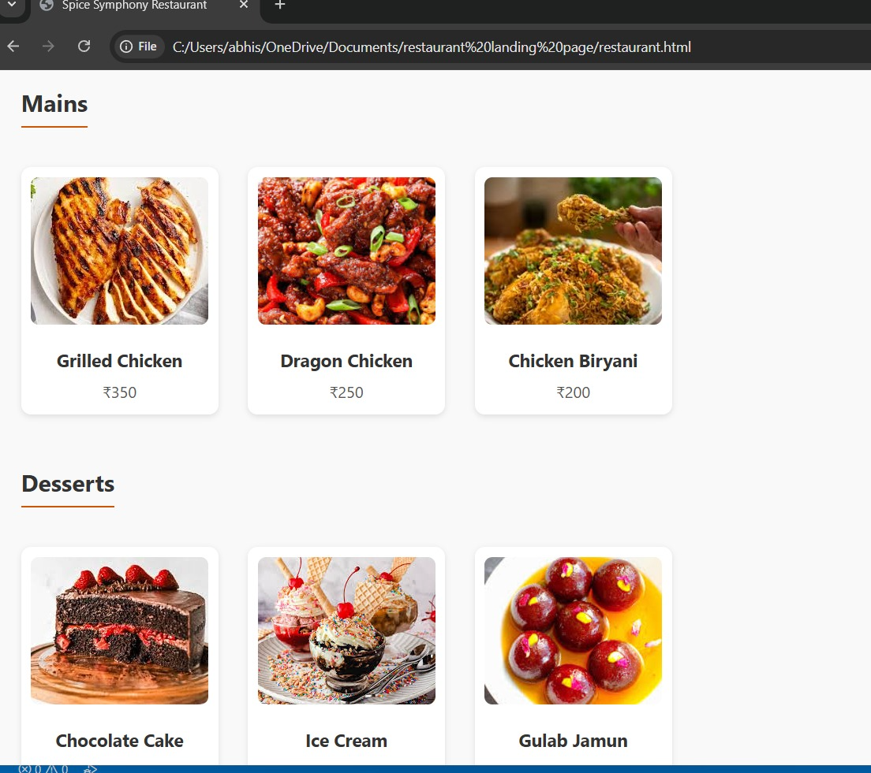

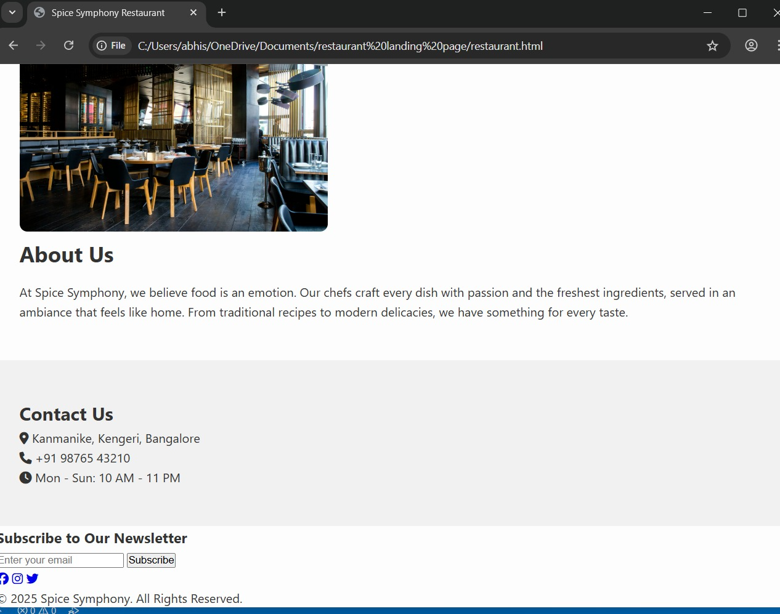

# Conclusion

The Restaurant Landing Page project demonstrated the importance of aligning design with brand identity. It served as a practical exercise in HTML5 and CSS3, focusing on responsive design, layout composition, and user engagement through visual elements.

# References

- L&T LMS: https://learn.lntedutech.com  
- Font Awesome: https://fontawesome.com  
- Unsplash: https://unsplash.com  
- W3Schools: https://www.w3schools.com